Introduction to Information Networks

TECH2100

Week: 12

Project Title: Multi-Router LAN with Wireless Integration and Port Security Simulation

Introduction
This project is part of the TECH2100 subject, Introduction to Information Networks, and aims to simulate a real-world enterprise network using Cisco Packet Tracer. The purpose of this project is to design and implement a secure, multi-segmented LAN with both wired and wireless connectivity, managed by multiple routers and switches. It incorporates core networking concepts such as IP addressing, routing protocols, wireless configuration, and network access control, aligned with the OSI and TCP/IP models.
In today's interconnected digital environment, the importance of securely designed networks cannot be overstated. This simulation models a small-scale organization with three departments, each assigned to its own subnet, managed through three separate routers. The objective is not only to ensure interconnectivity between these network segments but also to safeguard the network against unauthorized access — particularly from rogue wireless devices, a common real-world threat.
Wireless routers were integrated into two of the LAN segments to provide mobility to legitimate users. Additional focus was placed on enforcing security through port security, WPA2 encryption, and MAC address filtering. A simulated rogue laptop was introduced into the network to demonstrate how port security and wireless filtering mechanisms help detect and restrict unauthorized access attempts.
The expected outcomes of the simulation include:
- Establishing end-to-end connectivity across three LAN segments using dynamic routing (RIP).
- Configuring and validating secure wireless access for legitimate users.
- Demonstrating the effectiveness of port security in blocking unknown or unauthorized devices.
- Evaluating the overall architecture against core networking models and security practices.
This report walks through the design, implementation, testing, and reflection process. It highlights not only the technical execution but also the learning journey, challenges encountered, and the practical application of network security strategies in a simulated environment.
Purpose:
The primary aim is to create a secure and functional network that demonstrates LAN segmentation, inter-network routing, wireless access, and mitigation of unauthorized access using port security. The expected outcome is to simulate real-world networking environments where multiple departments are logically isolated, yet interconnected via routing.

Design Choices

Network Model Selection: OSI and TCP/IP
This project references both the OSI and TCP/IP layered models to explain network behavior:
- OSI Layer 2 & 3: Configurations on switches (data link) and routers (network layer).
- TCP/IP Model: Focused on Internet Layer (routing) and Link Layer (port security).
- Switches manage MAC-based communication, while routers handle IP routing between networks.
The models guide decisions regarding segmentation, data flow, and protocol implementations.

Addressing Scheme
The network is segmented into three subnetworks:
Device | Interface | Network | IP Address | Subnet Mask | Default Gateway
Router_Priyanka | Fa0/0 | Network A | 192.168.1.1 | 255.255.255.0 | N/A
Router_Sharma | Fa0/0 | Network B | 192.168.2.1 | 255.255.255.0 | N/A
Router_1854884 | Fa0/0 | Network C | 192.168.3.1 | 255.255.255.0 | N/A
Switch 1 | VLAN 1 | Network A | 192.168.1.2 | 255.255.255.0 | 192.168.1.1
Switch 2 | VLAN 1 | Network B | 192.168.2.2 | 255.255.255.0 | 192.168.2.1
Switch 3 | VLAN 1 | Network C | 192.168.3.2 | 255.255.255.0 | 192.168.3.1
PC-A | NIC | Network A | 192.168.1.10 | 255.255.255.0 | 192.168.1.1
PC-B | NIC | Network B | 192.168.2.10 | 255.255.255.0 | 192.168.2.1
PC-C | NIC | Network C | 192.168.3.10 | 255.255.255.0 | 192.168.3.1
Access Point 1 | LAN Port | Network A | 192.168.1.3 | 255.255.255.0 | 192.168.1.1
Access Point 2 | LAN Port | Network B | 192.168.2.3 | 255.255.255.0 | 192.168.2.1
Laptop 1 (Legitimate) | Wireless NIC | Network A | 192.168.1.20 | 255.255.255.0 | 192.168.1.1
Laptop 2 (Legitimate) | Wireless NIC | Network B | 192.168.2.20 | 255.255.255.0 | 192.168.2.1
Rogue Laptop | Wireless NIC | Network A | 192.168.1.35 | 255.255.255.0 | 192.168.1.1

Routing Protocols
The routers are interconnected using serial links and configured with the Routing Information Protocol (RIP v2):
- RIP is chosen for simplicity and compatibility.
- All routers advertise their directly connected networks.
Routing Configuration Example:
Router(config)# router rip
Router(config-router)# version 2
Router(config-router)# network 192.168.1.0
Router(config-router)# network 192.168.2.0
Router(config-router)# network 192.168.3.0

This enables communication between all three LAN segments.

Network Security Measures

1. Port Security on Switches
- Port security is enabled on all access ports connected to wired devices.
- Ports allow a maximum of 1 MAC address.
- Violation mode is set to shutdown for strict enforcement.
- Wireless router uplink port (Fa0/4) is limited to maximum 2 MAC addresses with violation restrict.
Sample Port Security Config:
Switch(config)# interface fa0/1
Switch(config-if)# switchport mode access
Switch(config-if)# switchport port-security
Switch(config-if)# switchport port-security mac-address sticky
Switch(config-if)# switchport port-security maximum 1
Switch(config-if)# switchport port-security violation shutdown

2. Wireless Security (Home Wireless Router)
- WPA2-PSK enabled with strong password.
- MAC address filtering enabled to allow only legitimate laptop.
- Rogue device is denied access automatically.

Quality of Service (QoS)
Due to the simplicity of the scenario and lack of real-time traffic, explicit QoS policies were not applied. However, the network topology is designed to:
- Minimize broadcast domains using routers.
- Limit device access to prevent bandwidth abuse (via port security and IP planning).

Simulation Outline

Devices and Setup
- 3 Routers (HWIC-2T modules installed):
  - Router_Priyanka, Router_Sharma, Router_1854884.3
- 3 Switches connected to respective LANs
- 3 PCs, each assigned to one LAN
- 2 Wireless Routers used to simulate access points
- 2 Laptops (legitimate and rogue)
- All routers interconnected via serial links

IP Configuration
- Static IPs used for all devices.
- Default gateways configured on each PC to point to their respective routers.

Routing
- RIP configured on all routers.
- Routers advertise LAN networks for full reachability.

Wireless Access
- SSID: Network_A_Wireless, Network_B_Wireless
- WPA2 Password: SecurePass123

Testing Conducted
- Pings between PC_A ↔ PC_B ↔ PC_C
- Wireless laptop successfully connects and pings router and PC in its LAN
- Rogue laptop denied access: ping fails and no IP address assigned
- show port-security confirms violation counts and blocked MACs

Screenshots
- [Screenshot 1: Network Topology]
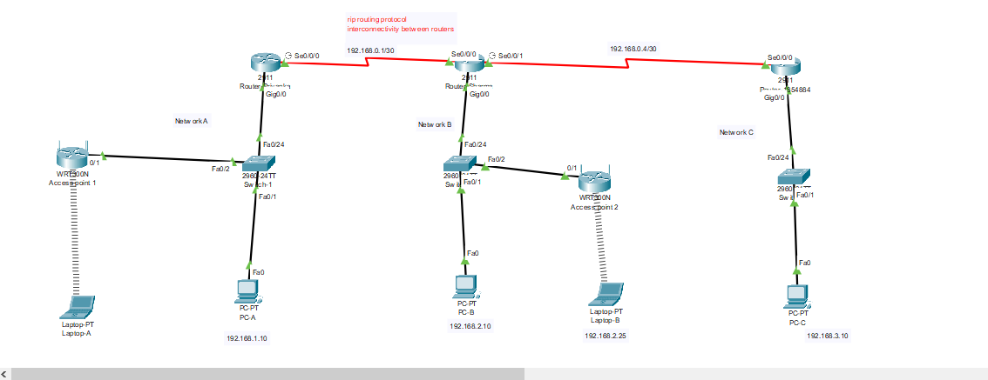
- [Screenshot 2: Router Configuration]
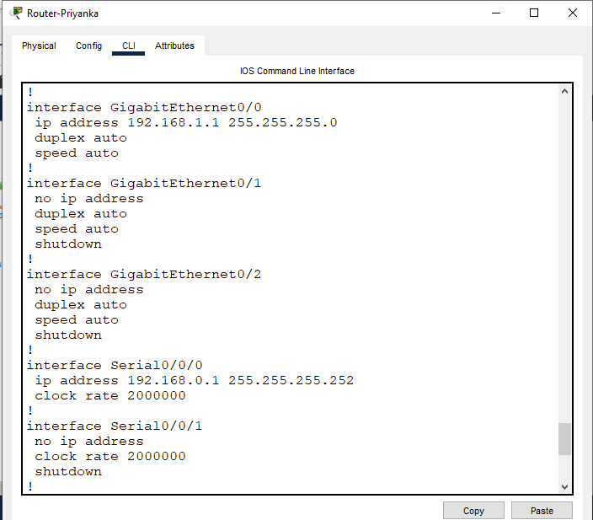

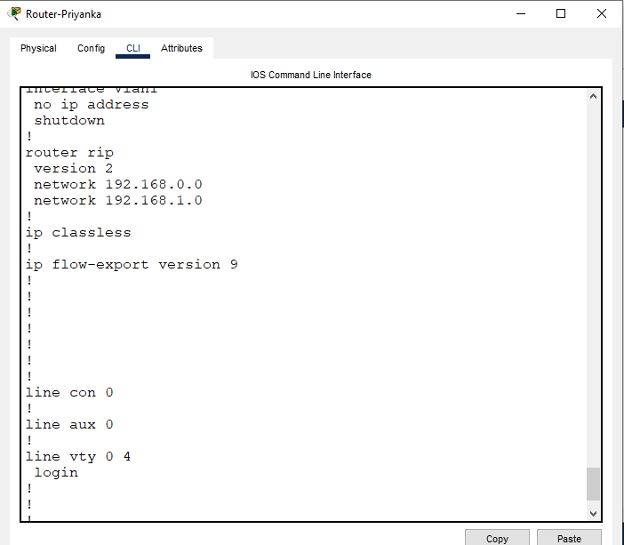

- [Screenshot 3: Switch Port-Security Config]
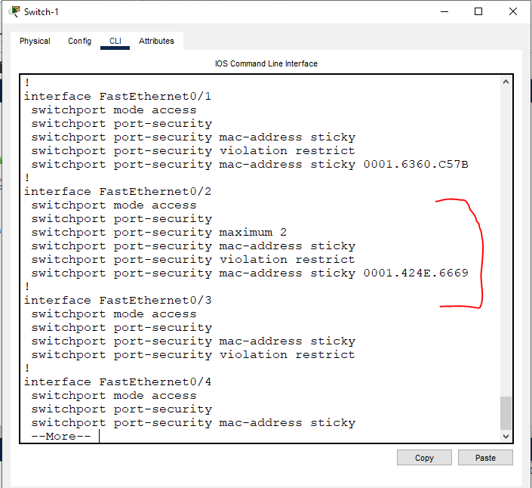
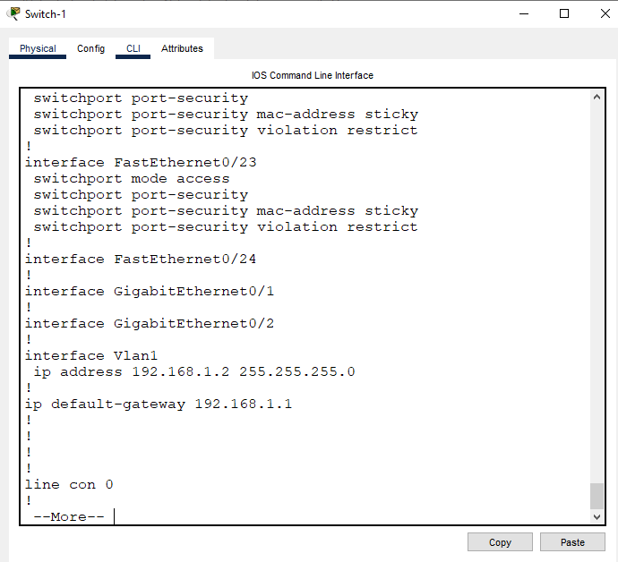

- [Screenshot 4: Wireless Router Setup]
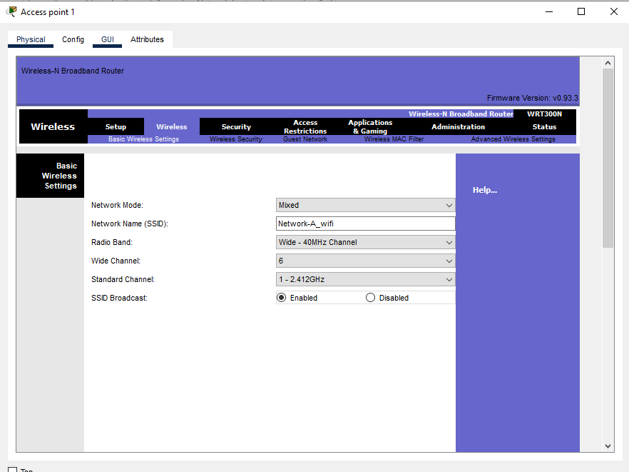
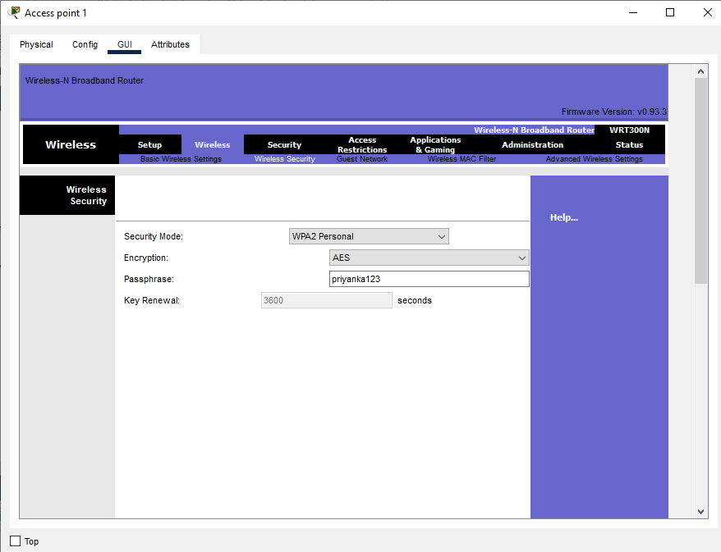

- [Screenshot 5: Rogue Device Denied Test]
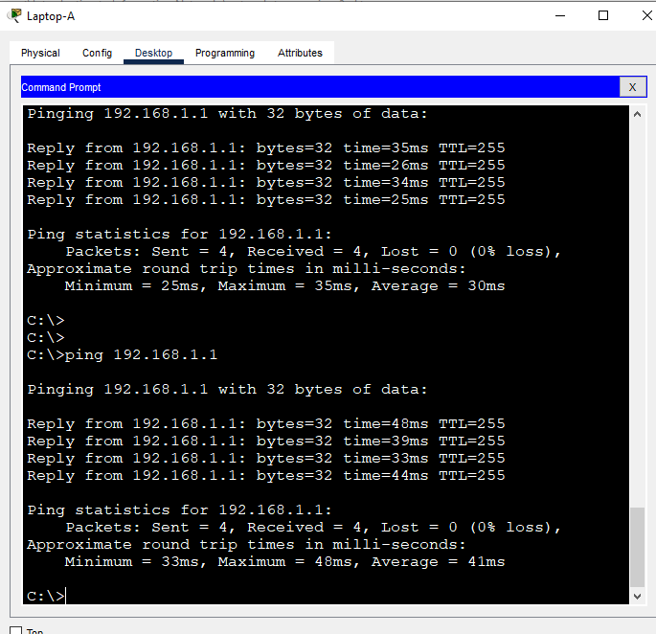

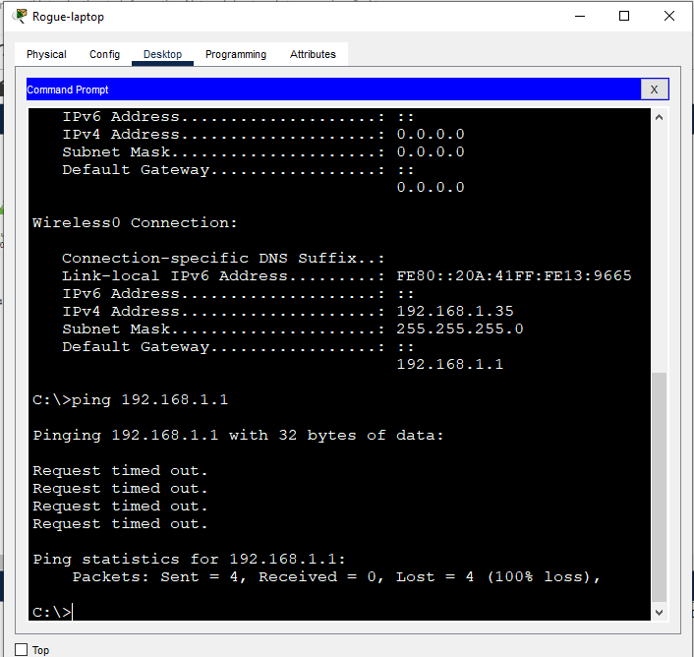
Rogue laptop restricted to access network although connected with wireless
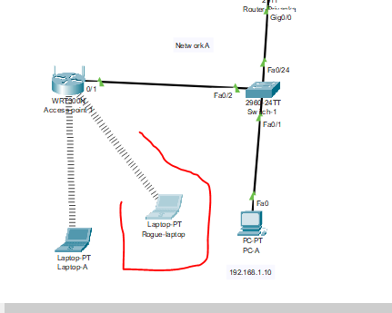

- [Screenshot 6: show port-security interface output]
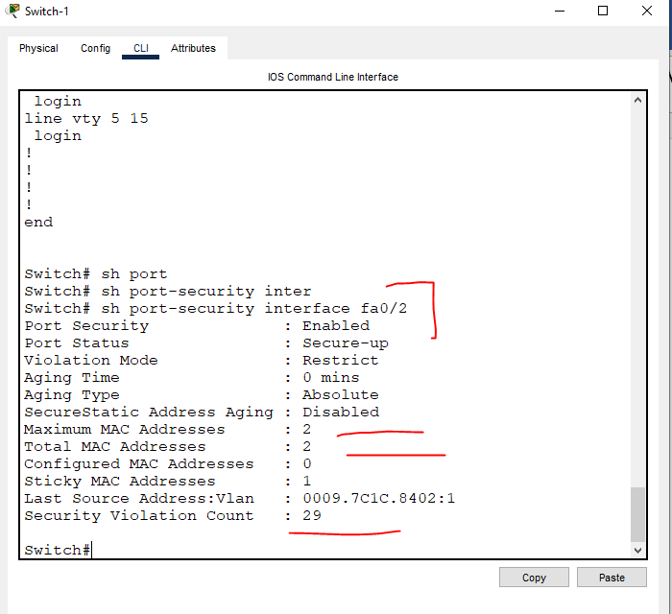

- [Ping PC-A to PC-B & PC-C Successfully
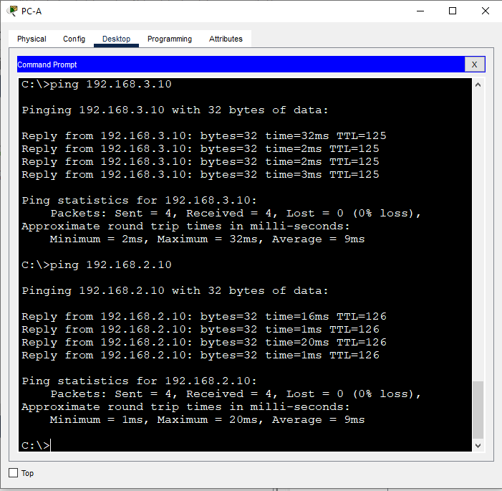

Challenges and Resolutions
During the development and simulation of this network, multiple technical challenges emerged, especially around implementing port security, managing wireless connectivity, and handling rogue device restrictions. This section outlines these challenges and the corresponding resolutions in detail, with the aim of demonstrating practical problem-solving in network design and security enforcement 1. Port Security Violations on Wireless Router Uplink Port
Challenge:
One of the first challenges encountered was that the switch port (Fa0/4) connected to the home wireless router kept entering a violation state despite proper configuration. This issue initially appeared confusing, especially since the port security commands were standard and worked well with other ports.
Upon closer inspection, the problem was traced to the fact that the wireless router acts like a miniature switch, forwarding packets from multiple wireless clients (each with a unique MAC address) through the same physical Ethernet uplink port to the switch. By default, port security was set to allow only one MAC address per port, which meant the second client (whether legitimate or rogue) would trigger a violation.
Resolution:
To resolve this, the port connected to the wireless router was reconfigured to allow up to two MAC addresses and set the violation mode to restrict instead of shutdown. This allowed two legitimate devices to connect through the wireless router without disabling the port entirely.
Switch(config)# interface fa0/4
Switch(config-if)# switchport port-security
Switch(config-if)# switchport port-security maximum 2
Switch(config-if)# switchport port-security mac-address sticky
Switch(config-if)# switchport port-security violation restrict
This configuration allowed legitimate wireless devices to connect while still blocking excess or unauthorized devices by quietly dropping their frames and increasing the violation count.

2. Rogue Laptop Access Denial Validation
Challenge:
After setting port security, confirming that the rogue laptop was indeed being blocked presented another challenge. The rogue device was configured with a static IP (192.168.2.25) and connected to the correct SSID and WPA2 password. However, it still appeared in the MAC address table, which caused confusion as it suggested the device was participating in the network.
Resolution:
It was discovered that although the rogue MAC appeared dynamically in the MAC address table (show mac address-table), it did not appear in the secure MAC list (show port-security address). This clarified the difference between MAC address learning and port security enforcement.
To validate that the rogue device was truly blocked:
- Ping tests were conducted from the rogue laptop to 192.168.2.1 and 192.168.2.10, all of which failed.
- The switch's violation counter (show port-security interface fa0/4) showed an increasing value, proving that traffic from the rogue device was being dropped.
- Only the MAC addresses of the legitimate devices appeared under show port-security address, confirming the rogue device was not authorized

3. Wireless Router Configuration Limitations in Packet Tracer
Challenge:
Another technical limitation was related to Cisco Packet Tracer’s Access Point device. Unlike real-world access points, the Packet Tracer version could not be assigned an IP address, did not support WPA2 encryption or MAC filtering, and lacked any GUI for fine-tuning wireless parameters.
Resolution:
To overcome this, the home wireless router (Linksys WRT300N) was used instead. This device supports:
- WPA2 authentication
- SSID configuration
- MAC address filtering
- IP assignment on the LAN interface
The wireless router was connected to the switch using one of its LAN ports (not the Internet/WAN port), and IP addressing was statically configured to match the LAN subnet (192.168.2.3). DHCP was disabled to prevent IP conflicts with the main router (Router_Sharma).
4. Connecting and Securing Legitimate Wireless Devices
Challenge:
Configuring the legitimate wireless laptop to connect securely was also non-trivial. In some early attempts, the laptop failed to communicate with the gateway despite successful association with the SSID.
Resolution:
The root cause was found to be a mismatch in the WPA2 pre-shared key and missing default gateway settings. Once the correct WPA2 key was configured and the IP address and gateway were set to 192.168.2.20 and 192.168.2.1 respectively, the device could communicate with both the router and the rest of the LAN.

Conclusion
The network simulation successfully demonstrated critical concepts of routing, LAN segmentation, wireless integration, and network security enforcement through port security. The design aligned with OSI and TCP/IP principles and emphasized secure connectivity using both wired and wireless technologies.

Subject Learning Outcomes Addressed
- LO1: Evaluated technologies such as RIP, port security, MAC filtering, and WPA2.
- LO2: Demonstrated layered models by aligning switch and router operations to OSI/TCP-IP layers.
- LO3: Identified and resolved network challenges like port shutdowns and rogue access.

References
- Cisco Networking Academy. (2020). Introduction to Networks Companion Guide (CCNAv7). Cisco Press.
– Offers in-depth explanations on using Cisco Packet Tracer, network models, addressing, and switching concepts.
- Odom, W. (2020). CCNA 200-301 Official Cert Guide, Volume 1. Cisco Press.
– Covers hands-on lab configuration using Packet Tracer including router setup, port security, and wireless connectivity.
- Cisco Systems. (n.d.). Cisco Packet Tracer: Networking Simulation Tool. Retrieved from https://www.netacad.com/courses/packet-tracer
– Official Cisco resource explaining the capabilities and use of Packet Tracer in educational environments.
- Forouzan, B. A. (2007). Data Communications and Networking (4th ed.). McGraw-Hill.
– A well-known academic source for OSI/TCP-IP model, addressing schemes, routing protocols, and layered communication systems.
- Cisco Systems. (n.d.). Configure Port Security on Cisco Switches. Retrieved from https://www.cisco.com/c/en/us/support/docs/lan-switching/port-security/12013-44.html
– Technical guide to configuring and troubleshooting port security in Cisco switch environments.
- TechTarget. (n.d.). What is Cisco Packet Tracer?. Retrieved from https://www.techtarget.com/searchnetworking/definition/Cisco-Packet-Tracer
– Describes the purpose and educational benefits of Packet Tracer in simulating enterprise networks.
- IEEE. (2016). IEEE 802.11-2016: Wireless LAN MAC and PHY specifications. Institute of Electrical and Electronics Engineers.
– Standards document detailing wireless access control (MAC filtering, WPA2) used in realistic wireless implementations.
- Tanenbaum, A. S., & Wetherall, D. J. (2011). Computer Networks (5th ed.). Pearson.
– Explores fundamental concepts in internetworking, routing, and wireless communications.
- Cisco Systems. (n.d.). Configure RIP Routing. Retrieved from https://www.cisco.com
– Step-by-step instructions on how to configure Routing Information Protocol (RIP) in small and medium-sized networks.
- Kaplan Business School. (2024). TECH2100 Subject Outline: Introduction to Information Networks. Kaplan Australia.
– Outlines learning objectives, assessment goals, and key theoretical foundations for the project.

